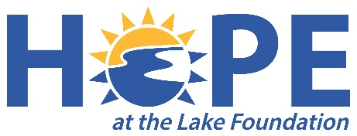
Hope at the Lake Foundation
Grant Proposal Guidelines

What is the Hope at the Lake Foundation?
​Hope at the Lake is a 501(c)(3) non-profit organization committed to improving the lives of our Lake Norman neighbors in need. Our mission is to facilitate a “community of caring” by connecting compassionate donors with immediate community need.
What are Grants?
Grants are financial awards to non-profit organizations serving Mooresville, North Carolina specifically, and the Lake Norman, North Carolina area in general. They are designed to help these organizations address identified community needs. Grants are awarded on a competitive basis.
Who is Eligible to Apply?
Organizations must be non-profit entities serving the areas described above. This includes 501(c) (3) public charities, local schools, local government entities, and religious organizations serving the public through non-religious public outreach.
What Types of Projects Qualify for Funding?
Grants support a wide variety of projects. We look for proposals that will make a substantial impact on our community in relation to the funding amount requested for the project. Our Board tends to avoid projects with a “drop in the bucket” feel, meaning that the requested grant will not significantly impact the community need at hand.
What Types of Projects do NOT Qualify for Funding?
Grants will NOT be provided for the following: religious activities, debt retirement, political organizations or campaigns, tickets for benefits, telephone solicitations, or organizations/projects working primarily to influence legislation. Proposals that do not comply with proposal guidelines are not eligible for Board review.
What does the Review Committee/Board look for in Proposals?
- A Clear and compelling demonstration of community need
- A reasonable, appropriate and well-developed program that will address the stated need
- A detailed, accurate accounting of where the money will be spent
- Evaluative tools and procedures that measure impact on the community need described in the proposal
- Evidence of appropriate collaboration with other organizations and groups that may help strengthen the project
When is the Proposal Deadline?
Proposals are accepted and reviewed on a quarterly basis, and will be publicized through various local channels. We recommend that you check our website periodically for updated information. The Foundation does not fund projects retroactively!
“Emergency” or proposals where “special circumstances” exist should be discussed with the Grant Coordinator, and may be accepted and reviewed at any time during the year based on need. Such applications should be the exception, rather than the rule.
What if I have questions?
Any questions can be addressed to our Grant Coordinator at mikebuccialia@hopeatthelake.org.

